Frances Watkins, Medical Herbalist
For immediate release Frances Watkins, Medical Herbalist
26 August 2022 Phone: 07976 609848
Email: f.watkins596@gmail.com
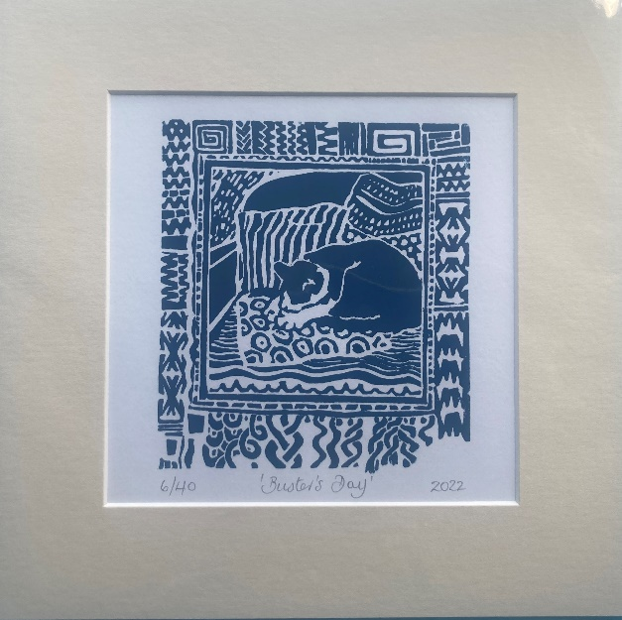
Buster’s Day
- An intricate handmade linocut designed by Non Shaw
- In memory of herbalists and educators Christopher Hedley and Non Shaw
- All proceeds to go to the Herbal History Research Network Student Travel Bursary
It is five years since Non and Christopher passed from this world and in memory of them both, with their families’ blessing, we have created a limited edition of one of Non’s linocuts titled ‘Buster’s Day’. Each image is individually handmade using a blend of blue and black inks, sequentially numbered 1 through to 40 and mounted on a 9 x 9 inch board. The reverse bears a label confirming the aim of this project and that Christopher and Non taught there is always something you can do to help others. Every print is enclosed in a cellophane wrap and will be posted in a padded envelope at a cost of £35 including post and packing and is only available for delivery in the UK.
We hope you will join in us remembering Christopher and Non and at the same time, support students who are unable to fund their travel expenses to future HHRN seminars. If you would like to buy one of these prints please email Frances Watkins at f.watkins596@gmail.com for details of how to pay.
The Herbal History Research Network (HHRN) aims to promote a scholarly approach in herbal history research which is systematic, objective and developmental. The HHRN also aims to connect people who share common interests in researching the history of herbal medicine, and to support their development of skills and access to herbal resources. All the proceeds from 'Buster's Day' will go to the HHRN Student Travel Bursary which will open for applications when dates are confirmed for the next physical seminar in 2023/24. Visit https://herbalhistory.org

